
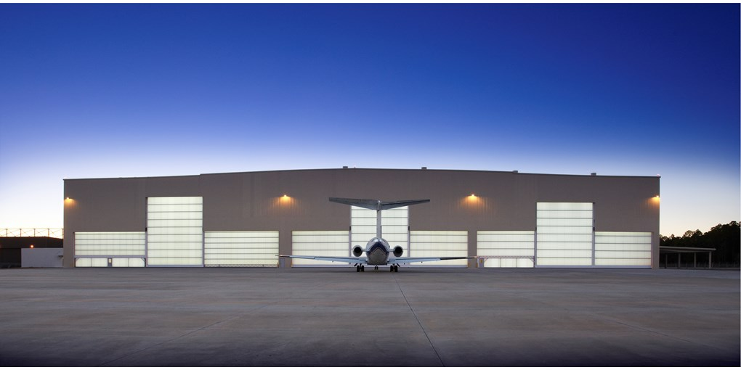
HANGAR Door @ AIR INDIA, TRIVANDRUM

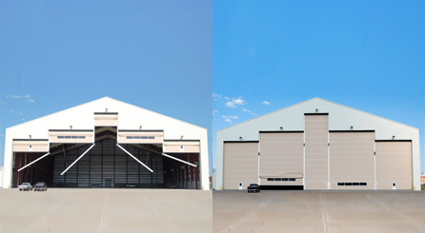

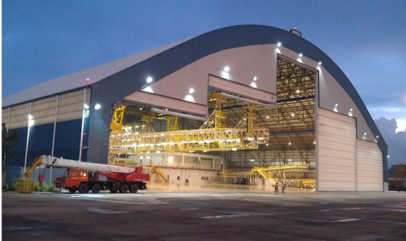

Sales Quotation

To, Date: 02.07.2019
Air India Engineering Services Quotation No: SQT/19-20/1771
Trivandrum

Kind Attn: Mr. K N Radhakrishnan (+91 9495803668)

Subject: Annual Maintenance Quotation for AIR INDIA Engineering Services. Hangar Door, Trivandrum

Dear Sir,

We thank you for giving us opportunity to provide you offer for AMC for Hangar Door .

Maintenance and service aren’t about what you get. They’re about what you avoid: failures, losses and unplanned interruptions.

Benefits:
- Prevents unexpected and expensive break-downs
- Prolongs lifetime
- Cost saving
- Minimizes risk of personal injury
- Minimizes energy loss
- Fulfills legal requirements

Escalation Chart.

Sr No. | Name | Designation | Mobile | E mail address
1 | Mr. Sagar Parkale | Project Head | 8551095333 | project@nihva.com
2 | Mr. Arjun Patil | Asst. Sales Manager | 8551096333 | arjun.patil@nihva.com

Annual Maintenance Quotation
- Scope of Work

  - Check condition of side guides and slide blocks.
  - Check condition of door fabric, intermediate beams and bottom seal.
  - Check condition of lifting belts.
  - Check operation of limit switches, clean and lubricate as required.
  - Check condition of motors including dust build up in the fans and oil levels.
  - Test the operation of the door using standard push buttons and any additional remote devices.
  - Check and test the safety arrestors.
  - Check and test any safety devices that are fitted.
  - Check the mullion joint.
  - Check the chain hoist.
  - Check list will be submitted after every service.

Visits

- NIHVA will carry out Three regular services and two emergency breakdown visits in one year to carry out above scope of works for Hangar Doors (Make- Mock Door)
- NIHVA will carry out Two Emergency breakdown visits without any charge for one year.

- The price is exclusive of supply of spare parts and consumables.

- Upon discovery of any parts to be replaced, Air India needs to release a separate order for the required spares and consumables.

Commercial Offer: -
Sr. No | Product | Year Considered | Rate/door/3visit/year  (INR) | Qty | Total Amount  (INR)
1 | Hangar Door (Mock Door) | 02.07.2019 –  01.07.2020 | 2,60,000 | 2 | 5,20,000

Quality & Safety:

“NIHVA” has always been strongly supported by world leaders in automation. Our commitment is to execute projects with highest quality, on time & within the budget while adhering to safety, health and environmental standards and to get established as an icon in providing best engineering, solutions, services and products.

NIHVA values its customers and their businesses and therefore has also built capabilities to provide after sales services. NIHVA is equipped with sophisticated tools and trained engineers to provide quick and efficient service to ensure minimum downtime, prevent unexpected breakdowns and safe work environment.

Prerequisites for Service - Client Scope

- The above terms do not apply in case of abuse, misuse, misapplication or any defects arriving due to negligence or accident. An extra cost will be applicable for Extra Man Power for extra. day (if required) + Spares & payable by you will be quoted separately.

- The above terms do not apply to such products which shall have been installed, altered, or Repaired by any non-authorized person

- Any spare part/ component (if) required, will be at extra costs are not inclusive in the maintenance contract.

- Required Forklift / Scaffolding and necessary help to our service Engineers from client during maintenance of each door in addition to any other charges or fees specified in this Agreement.

- Additional Costs and Charges: The cost of materials and repair if any or extra services shall be charged extra to Customer.

- In addition, on-site maintenance calls if following are the reasons

(A) in which the Equipment was not the cause of the reported trouble
(B) where no trouble was found
(C) where the call was due to Customer or its representatives improperly following operating instructions for the Equipment, will be billed separately.

- If due to any reason our person needs to wait beyond working duration, then Rs. 5,500/- per day working charges will be charged extra.

Terms & Conditions:
- GST: Extra 18%
- Validity: Validity of offer is 15 days from the date of quotation.
- Payment Terms: 100% advance immediately after the submission of Tax invoice

GST Pune: 27AAECN0437H1ZM
SAC Code: 998732

Please feel free to Contact Mr. Arjun Patil on 08551096333 for any further Clarification / Information in this Concern.

Regards,
Varsha
8551091333
NIHVA Technologies Pvt Ltd.

